Rosanna Cubs – Swimming night
LaTrobe Uni Swimming Pool
Tuesday 9th November, 6:20pm-8pm

On Tuesday 9th Nov, we’ll be going swimming at the LaTrobe Uni Indoor Sports Centre’s pool. Cubs will have the opportunity to do Level 1 or Level 2 Swimming. Cubs should look at the Swimmer Badge in their yellow book before the night to choose which level they’d like to try for. They can also look at http://www.rosannacubs.org/badge/badgeSwimmer.htm
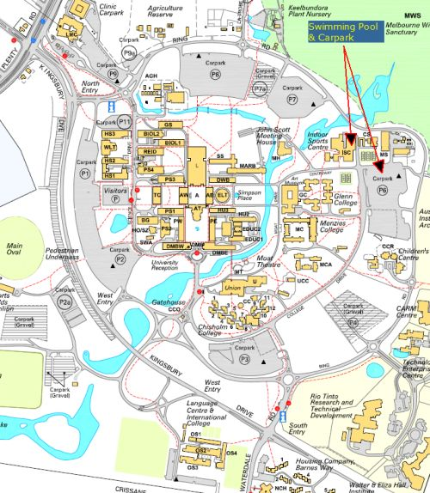
- Time: 6:20-8pm – Note different time to
normal Cubs
- Cost: Free this time!
- Location: Latrobe Uni Swimming Pool –
https://goo.gl/maps/vBrNU8MtYLq
Bring: Togs, Towel, warm clothes to go
home in
- Note: Cubs going for Level 2 Badge need
shorts and shirt, in addition to their
togs, to swim in and remove in the
water
Please be on time... we need the Cubs in the water by 6:30pm

Don’t miss out

Regards
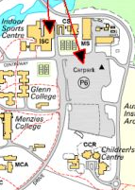
The Leaders
Rosanna Cub Scouts

See us at http://www.rosannacubs.org

